# Business Problems with Solution Query

**-- A. KPI’s**

**-- 1. Total Revenue:**

SELECT

ROUND(SUM(total_price)) AS "Total Revenue"

FROM pizza;

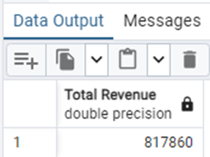

**-- 2. Average Order Value:**

SELECT

SUM(total_price) / COUNT(DISTINCT order_id) AS "Avg Order Value"

FROM pizza;

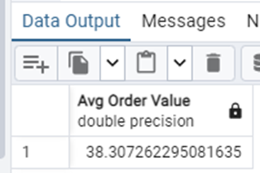

**-- 3. Total Pizzas Sold:**

SELECT

SUM(quantity) AS "Total Pizza's Sold"

FROM pizza;

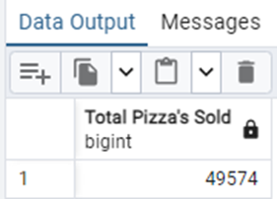

**-- 4. Total Orders:**

SELECT

COUNT(DISTINCT order_id) AS "Total Orders"

FROM pizza;

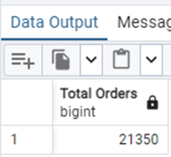

**-- 5. Average Pizzas Per Order:**

SELECT

ROUND(SUM(quantity)::numeric / COUNT(DISTINCT order_id), 2) AS "Average Pizzas Per Order"

FROM pizza;

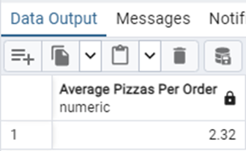

**-- B. Daily Trend for Total Orders:**

SELECT

TO_CHAR(order_date, 'Day') AS "Day of Week",

COUNT(DISTINCT order_id) AS "Total Orders"

FROM pizza

GROUP BY TO_CHAR(order_date, 'Day')

ORDER BY 2 DESC;

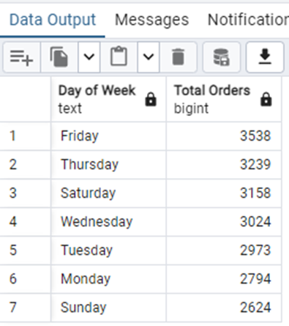

**-- C. Monthly Trend for Orders:**

SELECT

TO_CHAR(order_date, 'Month') AS "Month",

COUNT(DISTINCT order_id) AS "Total Orders"

FROM pizza

GROUP BY TO_CHAR(order_date, 'Month')

ORDER BY 2 DESC;

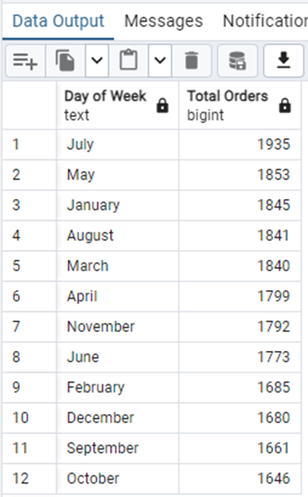

**-- D. % of Sales by Pizza Category:**

SELECT

pizza_category,

ROUND(SUM(total_price)::numeric, 2) AS "Total Revenue",

ROUND(

(SUM(total_price) * 100 / (SELECT SUM(total_price) FROM pizza))::numeric,

2

) AS "% of Sales by Pizza Category"

FROM pizza

GROUP BY pizza_category;

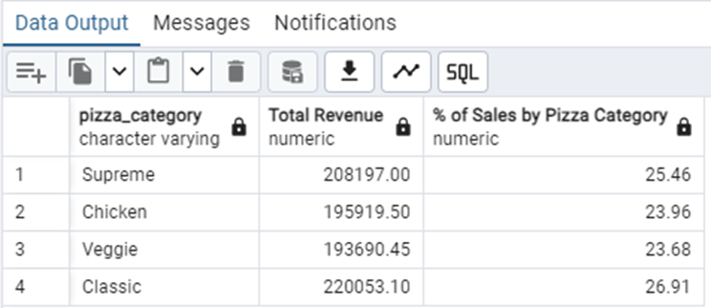

**-- E. % of Sales by Pizza Size:**

SELECT

pizza_size,

ROUND(SUM(total_price)::numeric, 2) AS "Total Revenue",

ROUND(

(SUM(total_price) * 100 / (SELECT SUM(total_price) FROM pizza))::numeric,

2

) AS "% of Sales by Pizza Size"

FROM pizza

GROUP BY pizza_size

ORDER BY 3 DESC;

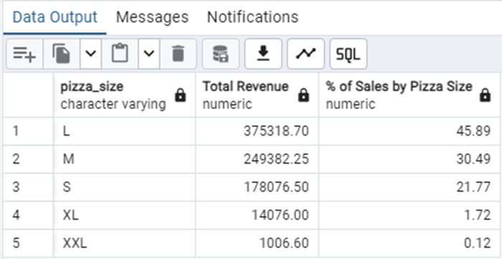

**-- F. Total Pizzas Sold by Pizza Category:**

SELECT

pizza_category,

SUM(quantity) AS "Total Pizzas Sold by Pizza"

FROM pizza

GROUP BY pizza_category

ORDER BY 2 DESC;

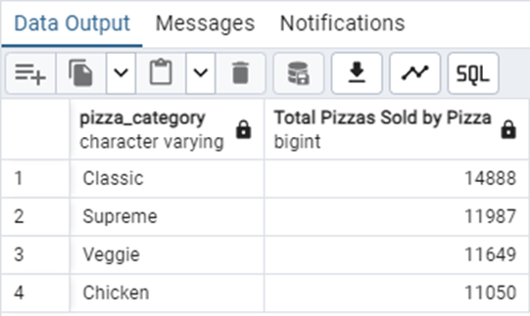

**-- G. Top 5 Pizzas by Revenue:**

SELECT

pizza_name,

SUM(total_price) AS "Total Revenue"

FROM pizza

GROUP BY pizza_name

ORDER BY 2 DESC

LIMIT 5;

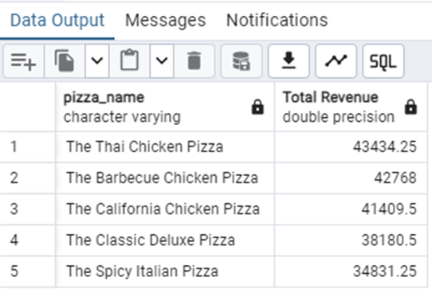

**-- H. Bottom 5 Pizzas by Revenue:**

SELECT

pizza_name,

SUM(total_price) AS "Total Revenue"

FROM pizza

GROUP BY pizza_name

ORDER BY 2 ASC

LIMIT 5;

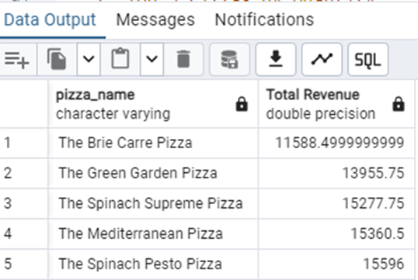

**-- I. Top 5 Pizzas by Quantity:**

SELECT

pizza_name,

SUM(quantity) AS Total_Pizza_Sold

FROM pizza

GROUP BY pizza_name

ORDER BY Total_Pizza_Sold DESC

LIMIT 5;

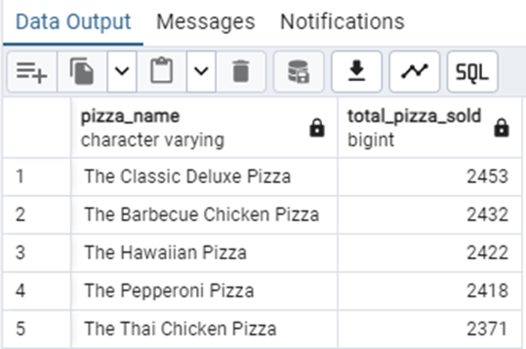

**-- J. Bottom 5 Pizzas by Quantity:**

SELECT

pizza_name,

SUM(quantity) AS Total_Pizza_Sold

FROM pizza

GROUP BY pizza_name

ORDER BY Total_Pizza_Sold ASC

LIMIT 5;

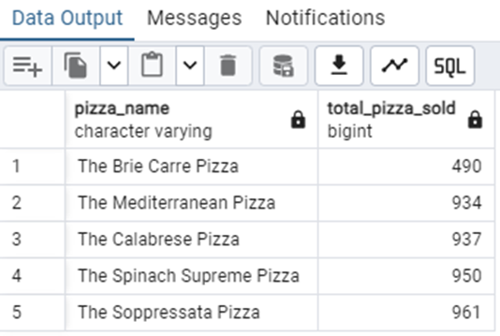

**-- K. Top 5 Pizzas by Total Orders:**

SELECT

pizza_name,

COUNT(DISTINCT order_id) AS "Total Orders"

FROM pizza

GROUP BY pizza_name

ORDER BY 2 DESC

LIMIT 5;

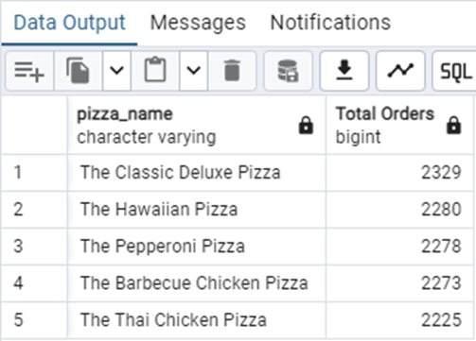

**-- L. Bottom 5 Pizzas by Total Orders:**

SELECT

pizza_name,

COUNT(DISTINCT order_id) AS "Total Orders"

FROM pizza

GROUP BY pizza_name

ORDER BY 2 ASC

LIMIT 5;

